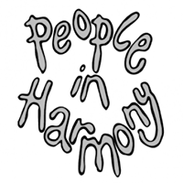

**A Call for Your Views** **as a mixed race person or as a mixed race family**

**Here is what we would like to know:**

1. Does being a mixed race person in 2019 mean that you experience Hate Crime?
2. Have you experienced racial harassment as a mixed race couple or family over this time?
3. Have things improved over 20 years since Stephen’s murder?
4. Has it got worse?
5. Have you as a mixed race person personally, or as a mixed race family, had any involvement or benefited from any projects, or services, as a result of Hate Crime? (i) What was it? (ii) How did it help you?
6. Did you report the incident? If no, why not?
7. Do you know of any groups or initiatives who have provided support to counter racism?
8. What more needs to be done?

Please send your comments to info@pih.org.uk no later than **Wednesday midday March 27,** stating the area you live in the UK here: This will help provide information making the case from both an urban and a rural perspective.

We’d like to hear from you to enable us to represent the views from the mixed race community.

Thank you,

Susann

Susann Savidge Chair

*For and on behalf of People in Harmony*

*For and on behalf of People in Harmony*

